Assignment 1 – Context Moat with Claude AI
Submitted by: Ismail Hossain
---------------------------------------------------------------------------------------------------------------------
Project: CRM Dashboard Experience Design
Output 1: Prompt with no context
Prompt link: Prompt_Without context_Github
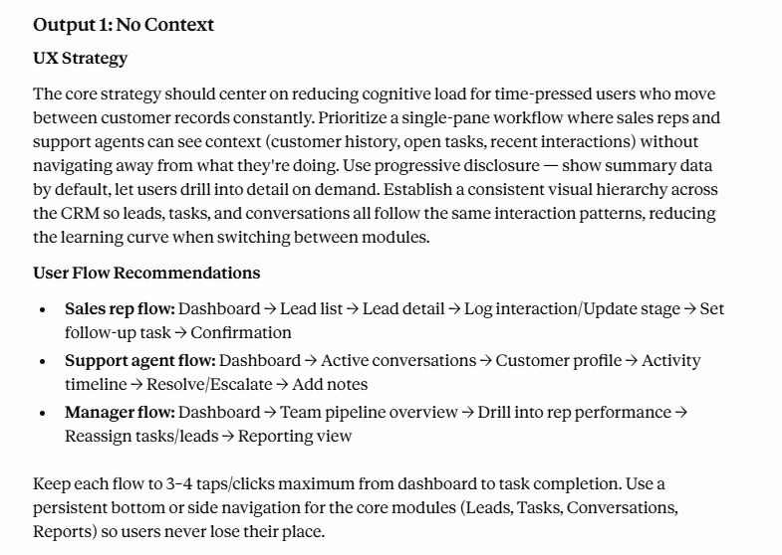 | 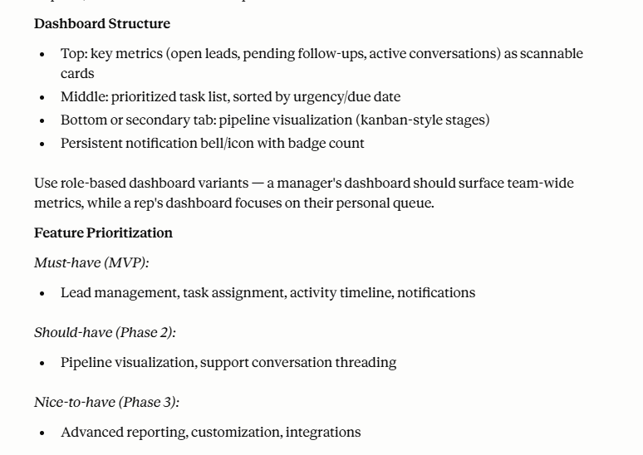 | 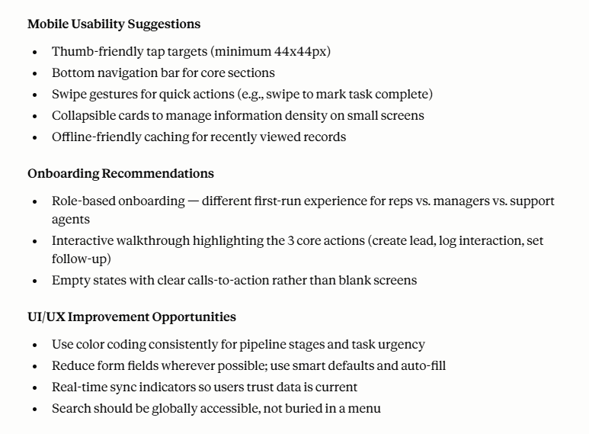

Observation:
The first output followed common global SaaS and enterprise CRM patterns. The recommendations focused more on advanced dashboard structures, kanban-style pipeline visualization, and feature-rich interactions while assuming stable internet connectivity and technically confident users.
---------------------------------------------------------------------------------------------------------------------
Output 2: Same prompt with context
Prompt link: Prompt_With context_Github
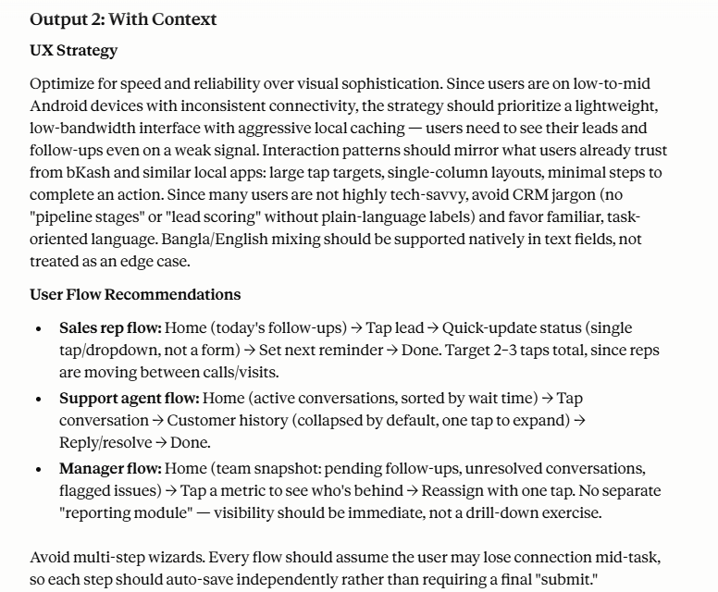 | 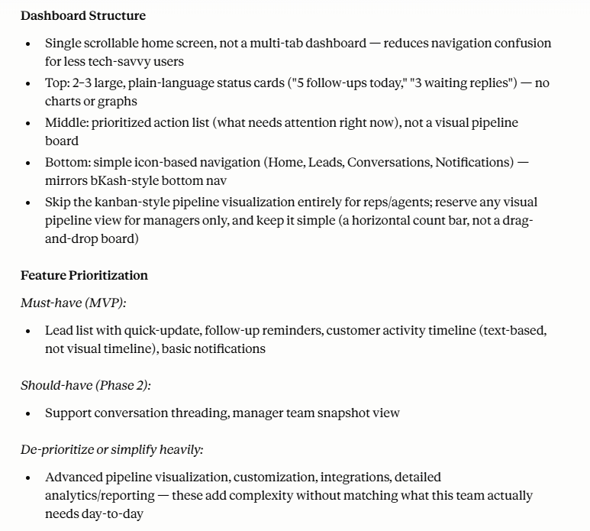 | 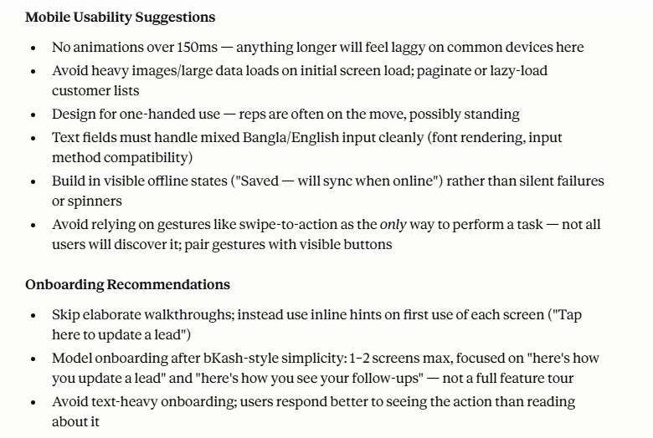
Observation:
After adding Bangladesh-specific user behavior, device limitations, workflow priorities, and operational realities, the recommendations became significantly more lightweight, mobile-first, operationally focused, and behavior-aware. The output prioritized usability, reminders, offline handling, and familiar interaction patterns over visually complex SaaS experiences.

What changed between without context and with context
- Claude initially assumed enterprise-style CRM usage with advanced dashboard patterns. After I added operational and user-behavior context, the recommendations became simpler and more task-focused.
- The generic output assumed stable internet connectivity and technically confident users. After I added low-end Android and inconsistent network constraints, Claude introduced lightweight interactions and offline-friendly behavior.
- Without context, the onboarding and navigation followed common global SaaS patterns. After adding familiar local behavior references like bKash-style simplicity, the UX became more direct and easier for non-technical users.
- The contextual version prioritized reminders, quick follow-ups, customer history visibility, and one-handed usability because I added real workflow behavior from sales and support teams.

My Context Moat
Working on CRM and operational SaaS products taught me that real user behavior is very different from the assumptions most AI-generated UX follows. In real workflows, sales and support teams often prioritize speed, quick follow-ups, and customer history visibility over visually complex dashboards or advanced features. I’ve also seen how many users access these platforms from low to mid-range Android devices while working in fast-paced environments with inconsistent internet connectivity. These practical realities and workflow behaviors are things Claude cannot naturally understand unless someone with real product experience intentionally provides that context.

